Community Players of Salisbury
Back Stage

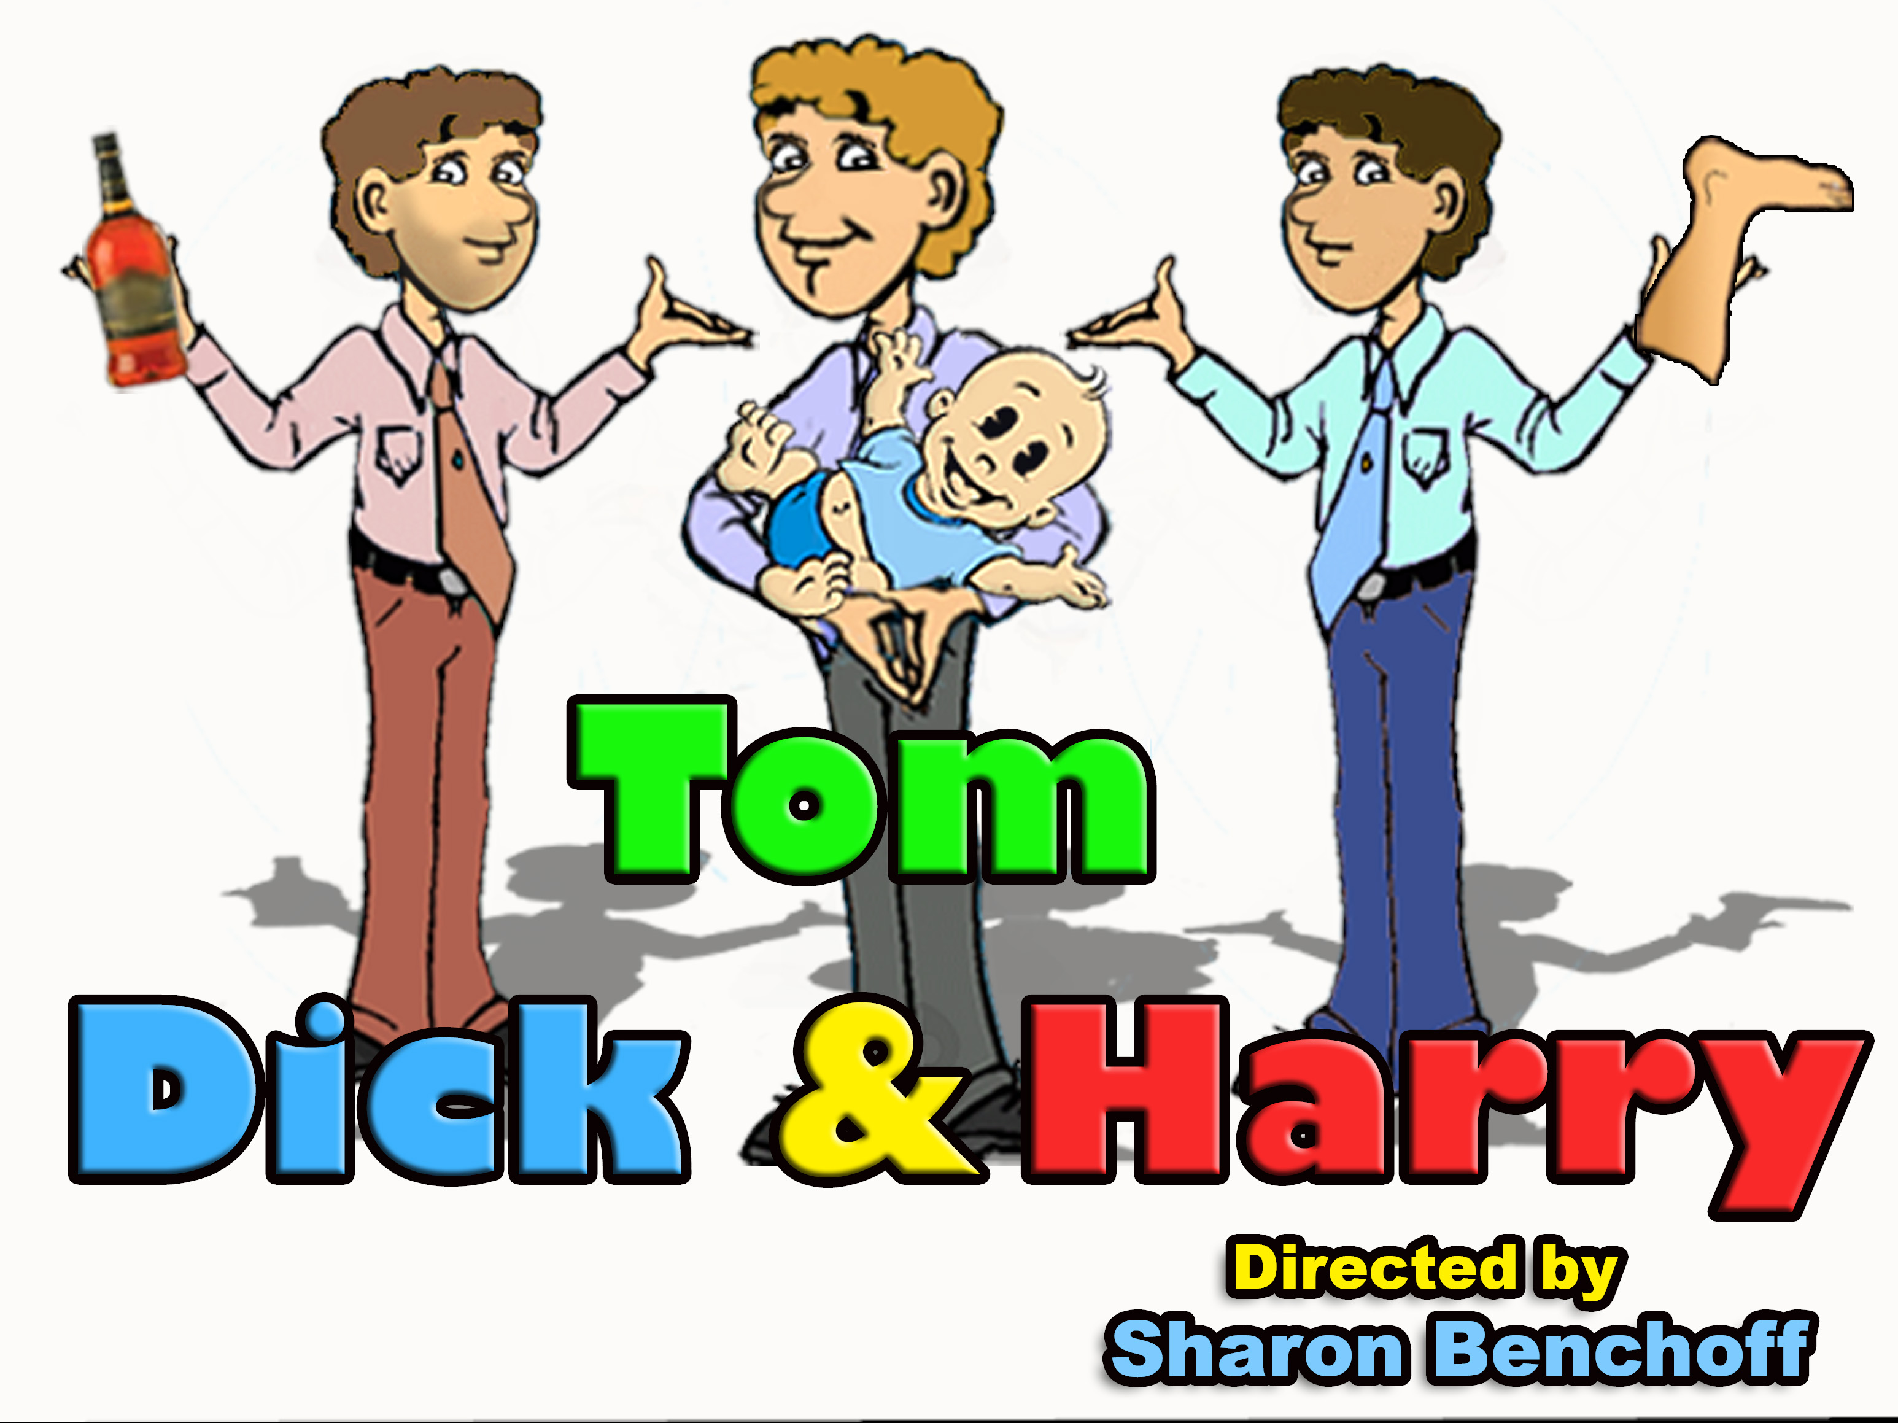
Tom Kerwood – a likeable Londoner trying his best to be the “mature” brother. Steady in his job and marriage, but his brothers try his patience and his sanity. He is preparing for the final interview conducted by Mrs. Potter who will allow the adoption of a baby.

Linda Kerwood – Tom’s wife. Smart, sparkly and sassy. She dearly loves Tom, but would be content not to see his brothers except perhaps at Christmas. She can be flippant, but not nasty or cold. She has a lot to deal with at the moment.

Dick Kerwood – Tom’s brother. A loveable rogue. The kind of guy that would be happy to lend you a hand moving, but would probably take all your beer from the refrigerator. If he would just put his schemes to lawful activities, he would be a success.

Harry Kerwood – Tom’s brother. Harry is a genius at brainstorming plans but not so much on the practical application. Can be rather thick at times. Has trouble holding down a job, but is a kind soul and means well.

Katerina – a Kosovan refugee in late twenties/early thirties. A poorly dressed peasant, buxom and attractive. She is confident, independent and cares deeply for her family and her Grandfather Andreas. (This character does not speak English. Her
dialogue is written phonetically. We are not going to worry that every word is pronounced correctly, but rather that the humor is found in her inflections)

Andreas – Grandfather of Katerina. A small shabby, weather beaten Kosovan refugee who drinks too much brandy and plays the trumpet (just a few notes) badly. (This character also does not speak English. His dialogue is written phonetically.)

Constable Downs – our local police officer. He knows something is amiss, but can’t quite put his finger on it. He does suspect that the three Kerwood brothers are less than sane. He appears intermittently throughout the play.

Mrs. Potter – a formidable professional lady in her fifties. She has the final word at the Adoption Agency. She tries her best to give Tom the benefit of the doubt when she arrives for her interview with the couple prior to authorizing Tom and Linda’s adoption of a baby.

Boris – Eastern European. Speaks English with a strong accent. He is “helping” Katerina and Andreas reunite with their family in London – for a price. He wants his payment and appears at the Kerwood home to collect.

AUDITIONS ANNOUNCED
TOM, DICK AND HARRY
Character Descriptions
Director Sharon Benchoff has announced the audition dates for this season’s spring production of “Tom, Dick, and Harry.” Auditions will be held in the Players’ Workshop on April 18 at 2 pm and on April 19th and 20th at 7 pm. The show dates are June 18th - 20th and June 25th -27th. If you are interested in trying out or helping in any way with the production, you can contact her at fresnelop@aol.com.
March 2010

Show Synopsis - In this hilarious story of three brothers, Tom and his wife are about to adopt a baby. His brothers are anxious to help make a good impression on the woman from the agency who has arrived to check on the home and lifestyle of the prospective parents. Unfortunately Dick, who has stashed boxes of smuggled brandy and cigarettes in the house, and Harry, who is in possession of a cadaver he is planning to sell illegally to a medical school, fail miserably. The adoption agency representative is aghast - and the illegal Croatian aliens who do not speak English are no help at all!















The View From Row G...
Well, we are now 2/3rds of the way through our 72nd season. Hard to believe but it is time to choose our shows for next season. It is time for us to nominate people for next season’s Board of Directors. And soon, you get to listen to Mandy comment here instead of me! (Not sure if that last one is a good thing or bad thing. Time will tell.)
But this season is far from over! At the next few meetings we will be looking at changes for our Constitution.
So if you are interested in how things at Players work. Now is the time to start paying attention at the monthly meetings.
The Building Committee has been working hard on some possible solutions to our lack of a theatre. They will be presenting what they’ve found out and their recommendations at upcoming meetings as well.
Our Membership is larger than I can remember it being the past few years. I am looking forward to seeing it con
Seeing it continue growing.
Lastly, I’d like to put in a plug to all of you active and concerned Players’ members. Nominations are now open for next year’s Board of Directors. See the article on the following page if you are interested in helping to lead Players’ into the future! Players is moving in some new and exciting directions. Why not be a part of it!!!!
Page 2
Visit a LORA restaurant! They support us during show weekends. Let’s show our support for them.
Visit www.lorarestaurants.com for locations.
March 2010

Wednesday, April 7
7:00pm
At the Workshop on Glen Ave
Come on out and hear what’s going on!
Membership Meeting

Need a Date Night Idea?

March 2010

Page 3

“FOXFIRE” WRAPS UP PRODUCTION
ELECTIONS
It’s that time of year again! If you are interested in nominating either yourself or someone else for a position on Player’s Board, please contact Pat Oberholtzer at patober@comcast.net. Nominations will be open until the end of the April 7th Player’s meeting. Elections will be held at the May meeting. Absentee ballots will be included in next month’s newsletter. Please remember that only paid members of Players over the age of 18 are eligible to vote or run for office. Positions open include - Vice President, Corresponding Sec., Recording Sec., Treasurer, and Board of Directors.

ACTORS WANTED
JMB is looking for AT LEAST 10-12 people willing to dress up in 1930’s identifiable characters for the Senior Prom on May 29th at 8pm until 10pm. For 2 hours of work, they are willing to make a donation to the group or to individuals. They need actors to walk around the prom being held at the Commons at Salisbury University portraying actors from the Black and White Era.

Contact Jan Bellistri at 410-546-4642 if this is something you'd be interested in. You would need to provide the costumes.

Some character suggestions would be: W.C. Fields and Mae West
Fay Wray and King Kong (we have a gorilla costume)
Charlie Chaplin
Laurel and Hardy

Briefly Stated
"FOXFIRE" has come to a close and is now just a memory. And what memories we have, from the Blizzard of 2010, to last minute set work, to shoveling snow and all of the finishing touches. The Cast did a great job, while having to miss so many rehearsals, due to the winter weather. Bobbie and Bob having roles that carried the bulk of the play, and at times changed the length of the show. Managed to pull it all together with the rest of the cast. They ALL did a very good job. I did enjoy my first attempt at directing, tho stressed by mother nature. I may still try directing again, at a later date. I would like to Thank those that stepped up to give a helping hand. Lisa Robins, Tom Robinson, David Allen, Mary Veise, Sammy Barns, and fast w/ the paint Tracy Kelly. I also owe Joann Little and Sherri Trader-Hynes , a big thank you for all they did with the "Band", props and Costumes. For now, it's over, packed up and put away. Just another memory of what I think was a good show.
at a later date. I would like to Thank those that stepped up to give a helping hand. Lisa Robins, stepped up to give a helping hand. Lisa Robins, Tom Robinson, David Allen, Mary Veise, Sammy Barns, and fast w/ the paint Tracy Kelly. I also owe Joann Little and Sherri Trader-Hynes , a big thank you for all they did with the "Band", prop's and Costumes. For now, it's over, packed up and put away. Just another memory of what I think was a good show.
Lester Huss

I just wanted to say thank you to everyone who assisted with the success of Foxfire, especially Lisa Robbins for coming it at the last minute to help paint the set… and anyone else who helped and whose name did not make it into the program. Hats off to the entire cast and crew for making it such a “beautiful show”. We had so many compliments afterwards, and lots laugh and more importantly, lots of tears… What more can you say.
Sherri Hynes
Shirley Temple
Claudette Colbert as Cleopatra
Fred Astaire and Ginger Rogers
Groucho and Harpo Marx
Douglas Fairbanks
Humphrey Bogart
ALSO:
They are looking for a few actors interested in singing and acting out scenes of the songs from South Pacific for a luncheon at Asbury United Methodist Church on Thursday, April 29th from around noon to 2pm. The theme is "South Pacific" and they'd love to have entertainers sing and dance to a few famous songs from the show...."Some Enchanted Evening" and "Wash that Man Right Outta My Hair" are songs that come to mind. They'd like enough songs to fill up about 20 minutes of entertainment.
Contact Jan if you are interested. Again, this could be a paying gig.


We’re on the Web: www.communityplayersofsalisbury.org
Community Players of Salisbury
PO Box 2431
Salisbury, MD 21803-2431

Non Profit Org.
US Postage Pd
Permit #176
Need to Contact Someone? Here’s How.
President: Ken Johnson - kjohnson71063@gmail.com
Vice President: Mandy Welch-Hamill - actwelch@aol.com
Recording Secretary: Kel Nagel - kelnagel@yahoo.com
Corresponding Secretary: Brenna Johnson - brennacjohnson@gmail.com
Treasurer: Charlie Linton - charliecamtransport@yahoo.com
Immediate Past President: Sharon Benchoff - fresnelop@aol.com
David AllenLester HussSherri HynesErnie Matthews
Kathy PanchykLisa RobbinsTom Robinson

